Technical Documentation

Architecture Diagram

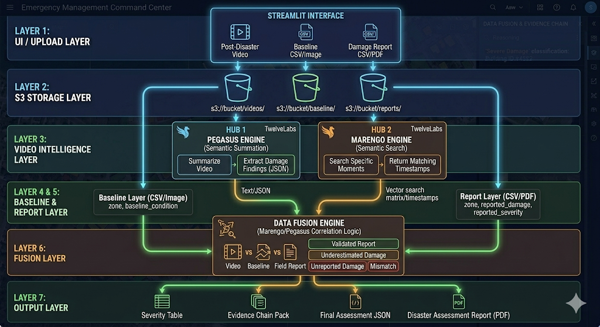

Correlation methodology: how relationships are identified across data types
1. Unified Multi-Modal Indexing
All input data streams are ingested and vectorized by standard TwelveLabs Marengo embeddings (multi-modal indexing pass).
- Video Finding (V): A specific visual scene (e.g., " mobile homes submerged") is translated into a dense semantic vector.
- Report Finding (T): A row extracted from a PDF field report (e.g., "mobile home cluster... total loss expected") is also translated into a dense semantic vector.
The key requirement is that Vector (V) and Vector (T) now inhabit the same mathematical dimensionality.
2. Final Fusion States
Only after passing all steps is the relationship categorized and pushed to the Output Layer
- Validated Report: AI findings and the PDF report are semantically adjacent and geographically aligned.
- Discovery: Unreported Damage: A high-priority video finding (e.g., "Destroyed beachfront Row") has NO semantically adjacent vectors found in any ingested ground reports for that specific location zone.
- Mismatch ALERT: The visual finding and report are semantically adjacent (describing the same thing at the same location) but conflict in severity (e.g., AI says Severe vs. Human Report says Minor).
Video processing approach: TwelveLabs API usage for extraction and analysis
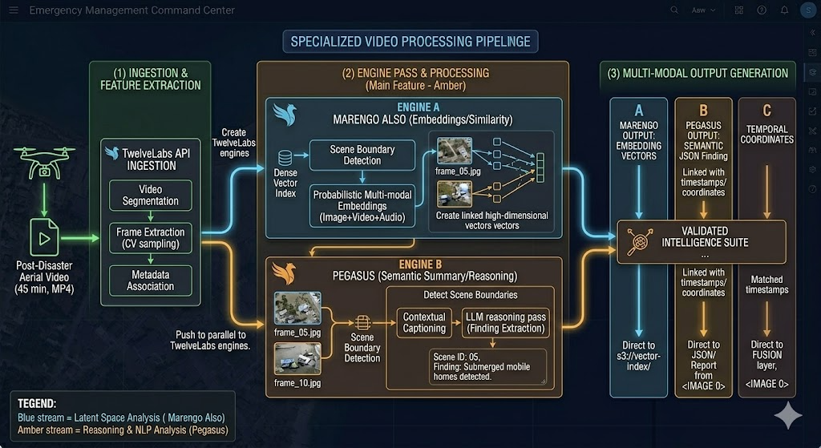

Entity Resolution across post-disaster video, baseline imagery, and unstructured PDF ground reports is achieved through a multi-stage fusion pipeline. Since this system is probabilistic (using AI embeddings rather than rigid keywords), a standard string comparison ("San Carlos Blvd" == "San Carlos Blvd") is insufficient.
Instead, the system utilizes Multi-Modal Vector Adjacency Mapping (Correlation) constrained by Geospatial Locality Checks.
This hybrid method ensures high-confidence entity matching, solving the problem of high semantic ambiguity and geographically duplicate names.
Stage 1: Latent Semantic Adjacency (Similarity)
The system first establishes that two entities are similar in their description or visual state using Multi-Modal Vector Embeddings (Layer 6 logic, Image 9).
- Operation: The system receives a high-dimensional Video Vector (AI sees submerged homes in scene 1) and a set of Text Vectors extracted from ingested PDFs. It calculates the semantic distance (e.g., cosine similarity) between them.
- Correlation Detection: Vectoris found to be semantically adjacent (e.g., probability score of 0.94) to Text Vector
Outcome: A high-probability relationship is detected; the system confirms these two sources are describing the same semantic reality ("Destroyed Mobile Homes"). However, they are not yet confirmed to be the same unique real-world entity (as there may be duplicate locations).
Stage 2: Location-Aware Locality Constrains (Entity Resolution)
To fully resolve the relationship, the system applies strict Geospatial Gazetteering.
- Metadata Extraction (Layer 5/6 logic): When inputs were ingested (Layer 2, Image 9), the system extracted metadata.
  - For the Video Scene: Spatial data (e.g., temporal coordinates/zone name extracted as "Arcadia South").
  - For the matched Report: Geographical data (e.g., "ZONE" extracted from the PDF table as "Arcadia South").
- Resolution: The potential relationship from Stage 1 is only fully fused if the spatial locality aligns. In this case, the Video Scene "ZONE" ("Arcadia South") matches the PDF Report "ZONE" ("Arcadia South").
Output: Finalized Entity States
Only after passing both constraints (semantic proximity and geospatial alignment) is the relationship fully resolved and pushed to the Output Layer. This process is visualized in the Fusion Engine (Image 9) logic:
- Validated Entity: Both constraints are met.
- Mismatch ALERT (Example): Video Vector (AI sees breakage on San Carlos Blvd) is semantically mapped to the "San Carlos Blvd" ground report, but the PDF lists the severity as "Minor" (contradicting the AI's "Severe" assessment). The system resolves the location (Entity Resolution) but flags the conflict.
- ALERT: Unreported Damage Discovery (Example): High-priority Video Vector (AI sees "Destroyed mobile homes") has NO semantically adjacent vectors found in any ingested ground reports for that specific location zone. The location is known, but the report is missing.
This hybrid approach allows the system to operate probabilistic AI (Marengo) within the rigid, location-deterministic requirements of a FEMA workflow.

